**[About WDD](https://worlddiabetesday.org/about/)**

**World Diabetes Day (WDD)** was created in 1991 by IDF and the World Health Organization in response to growing concerns about the escalating health threat posed by diabetes. World Diabetes Day became an official United Nations Day in 2006 with the passage of United Nation Resolution 61/225. It is marked every year on **14 November**, the birthday of Sir Frederick Banting, who co-discovered insulin along with Charles Best in 1922.

WDD is the world’s largest diabetes awareness campaign reaching a global audience of over 1 billion people in more than 160 countries. The campaign draws attention to issues of paramount importance to the diabetes world and keeps diabetes firmly in the public and political spotlight.

The World Diabetes Day campaign aims to be the:

* Platform to promote IDF advocacy efforts throughout the year.
* Global driver to promote the importance of taking coordinated and concerted actions to confront diabetes as a critical global health issue

The campaign is represented by a [**blue circle logo**](https://worlddiabetesday.org/resources/wdd-2019/logo/) that was adopted in 2007 after the passage of the UN Resolution on diabetes. The blue circle is the global symbol for diabetes awareness. It signifies the unity of the global diabetes community in response to the diabetes epidemic.

Every year, the World Diabetes Day campaign focuses on a dedicated theme that runs for one or more years. The theme for World Diabetes Day 2021-23 is **Access to Diabetes Care**.

[**Theme**](https://worlddiabetesday.org/about/theme/)

The theme for **World Diabetes Day** **2021-23** is **Access to Diabetes Care**.

* Millions of people with diabetes around the world do not have access to diabetes care.
* People with diabetes require ongoing care and support to manage their condition and avoid complications.

We cannot wait any longer for:

* Medicine, technologies, support and care to be made available to all people with diabetes that require them.
* Governments to increase investment in diabetes care and prevention.

In 2023, the campaign will focus on the importance of **knowing your risk of type 2 diabetes** to help delay or prevent the condition and highlighting the **impact of diabetes-related complications** and the importance of having access to the right information and care to ensure timely treatment and management.

**FACTS & FIGURES**

The [**IDF Diabetes Atlas**](https://www.diabetesatlas.org/) provides the latest figures, information and projections on the global impact of diabetes.

* **537 million adults** (1 in 10) were living with diabetes in 2021. This number is expected rise to **643 million** by 2030 and **783 million** by 2045.
* Almost **1 in 2 adults (44%)** with diabetes remain undiagnosed (240 million). The majority have type 2 diabetes.
* More than **3 in 4 people with diabetes** live in low and middle-income countries.
* **541 million adults** are at increased risk of developing type 2 diabetes.
* More than **1.2 million children and adolescents** (0-19 years) live with type 1 diabetes
* Diabetes caused **6.7 million deaths** in 2021.
* Diabetes was responsible for at least **$966 billion in health expenditure** in 2021 – 9% of the global total spent on healthcare.
* **1 in 6 live births (21 million)** are affected by high blood glucose (hyperglycaemia) in pregnancy.

[**Key messages**](https://worlddiabetesday.org/about/key-messages/)

**KNOW YOUR RISK, KNOW YOUR RESPONSE**

The theme for World Diabetes Day 2021-23 is **access to diabetes care**.

In 2023, the campaign focuses focuses on the importance of **knowing your risk of type 2 diabetes** to help delay or prevent the condition and highlighting the **impact of diabetes-related complications** and the importance of having access to the **right information and care** to ensure timely treatment and management.

**1 in 10 adults worldwide have diabetes. Over 90% have type 2 diabetes. Close to half are not yet diagnosed.**

In many cases, type 2 diabetes and its complications can be delayed or prevented by **adopting and maintaining healthy habits**. When not detected and treated early, diabetes can lead to serious and potentially life-threatening complications.

* For **people at risk of type 2 diabetes**, knowing your risk and what to do is important to support prevention, early diagnosis and timely treatment.
* For **people living with diabetes**, awareness and access to the correct information and best available medicines and tools to support self-care is vital to delay or prevent complications.
* For **healthcare professionals**, access to sufficient training and resources is required to detect complications early and provide the best possible care.

**WORLD DIABETES DAY PARTNERS**

Partners of the International Diabetes Federation (IDF) help to make World Diabetes Day a global success by providing valuable support for many of the activities taking place around the world. IDF is pleased to have the support of

the following partners for World Diabetes Day 2023

[**Reducing the risk of type 2 diabetes**](https://worlddiabetesday.org/about/prevention/)

**Type 2 diabetes accounts for over 90% of all diabetes.** There are several steps that can be taken to reduce the risk of developing the condition.

**Unhealthy eating habits and sedentary lifestyles** associated with urbanisation are common factors contributing to the development of type 2 diabetes. There is overwhelming evidence from studies in the USA, Finland, China, India and Japan that lifestyle changes (achieving a healthy body weight and moderate physical activity) can help prevent the development of type 2 diabetes in people at risk.

Reducing the risk of type 2 diabetes involves a **balanced diet and regular physical activity**. Maintaining a **healthy weight** is crucial as overweight and obesity increases the risk. Even a small weight loss can make a big difference. **Regular screenings and check-ups**, especially for people with one or more of the risk factors, can detect early signs and help individuals make the necessary changes to delay or prevent the onset of type 2 diabetes.

**RISK FACTORS FOR TYPE 2 DIABETES**

Several risk factors have been associated with **type 2 diabetes** and include:

* Family history of diabetes
* Overweight
* Unhealthy diet
* Physical inactivity
* Increasing age
* High blood pressure
* Ethnicity
* Impaired glucose tolerance (IGT)*
* History of gestational diabetes
* Poor nutrition during pregnancy

*Impaired glucose tolerance (IGT) is a category of higher than normal blood glucose, but below the threshold for diagnosing diabetes.

**KNOW YOUR RISK OF TYPE 2 DIABETES**

Brief questionnaires are simple, practical and inexpensive ways to quickly identify people who may be at a higher risk of type 2 diabetes and who need to have their level of risk further investigated.

**[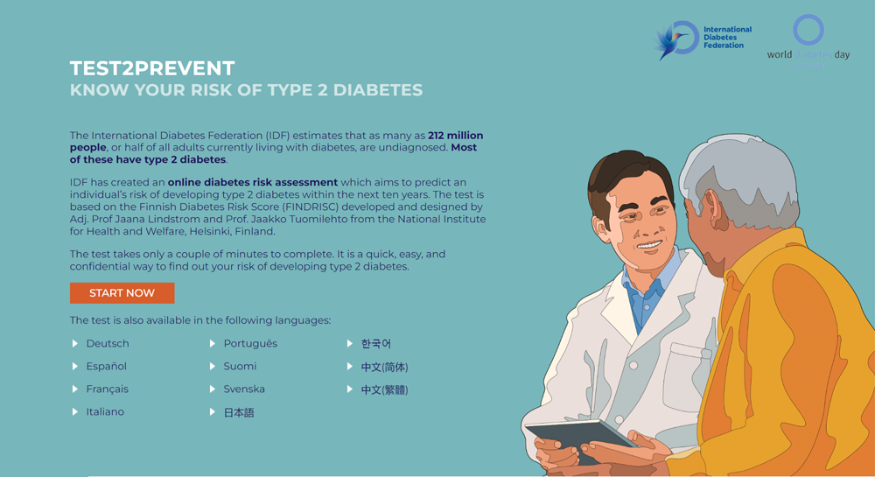](https://worlddiabetesday.org/type-2-diabetes-risk-assessment/)**IDF has developed an [**IDF type 2 diabetes online diabetes risk assessment**](https://www.idf.org/type-2-diabetes-risk-assessment/) which aims to predict an individual’s risk of developing type 2 diabetes within the next ten years. The test is based on the Finnish Diabetes Risk Score (FINDRISC) developed and designed by Adj. Prof Jaana Lindstrom and Prof. Jaakko Tuomilehto from the National Institute for Health and Welfare, Helsinki, Finland.

**IDF RECOMMENDATIONS FOR A HEALTHY DIET FOR THE GENERAL POPULATION**

* Choosing water, coffee or tea instead of fruit juice, soda, or other sugar sweetened beverages
* Eating at least three servings of vegetable every day, including green leafy vegetables
* Eating up to three servings of fresh fruit every day
* Choosing nuts, a piece of fresh fruit, or unsweetened yoghurt for a snack
* Limiting alcohol intake to a maximum of two standard drinks per day
* Choosing lean cuts of white meat, poultry or seafood instead of red or processed meat
* Choosing peanut butter instead of chocolate spread or jam
* Choosing whole-grain bread, rice, or pasta instead of white bread, rice, or pasta
* Choosing unsaturated fats (olive oil, canola oil, corn oil, or sunflower oil) instead of saturated fats (butter, ghee, animal fat, coconut oil or palm oil

**PHYSICAL ACTIVITY**

Any movement is good, and more is generally better, to reduce the risk of type 2 diabetes. You should aim for at least 150 minutes of moderate-intensity aerobic exercise (e.g., walking, jogging, swimming or cycling) per week, spread out over several days, possibly in shorter bouts of 10-15 minutes.Strength training also has its advantages. You can increase muscle mass and improve insulin sensitivity and glucose control by using weights or resistance bands to strengthen muscles.

[**Understanding diabetes**](https://worlddiabetesday.org/about/understandingdiabetes/)

Diabetes currently affects one in ten people worldwide. Understanding the condition is the first step towards managing and preventing it. In conjunction with the World Diabetes Day 2022 focus on access to diabetes education, the IDF School of Diabetes has developed a [**new online education platform**](https://www.understandingdiabetes.org/) to help people with diabetes and those who care for them to make informed decisions about their condition.

**[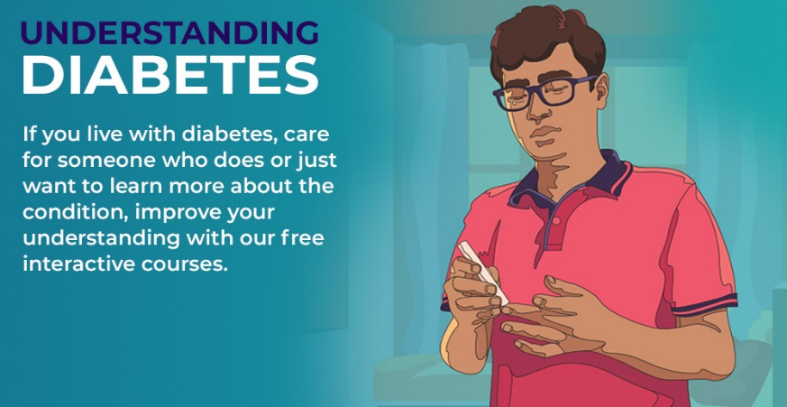](https://www.understandingdiabetes.org/)**

The **Understanding Diabetes** platform features a selection of free interactive courses on various aspects of diabetes care and management.

The first course – **An Introduction to Diabetes** – explains how the condition develops in the body, describes the main types and explores the warning signs, risk factors and complications.

The second course – **The** **basics of blood glucose control** – looks at the importance of keeping blood glucose levels in the target range as much as possible to help prevent or delay long-term complications of diabetes.

Other courses will subsequently be made available.

[**ACCESS THE PLATFORM**](https://www.understandingdiabetes.org/)

**HEALTH PROFESSIONAL EDUCATION**

The **IDF School of Diabetes** offers a selection of free and premium online courses to help healthcare professionals keep up-to-date with various aspects of diabetes management and treatment.

Free courses currently available include:

* [**Diabetes and cardiovascular disease**](https://idfdiabeteschool.org/free-courses/16/en-us)
* [**Diabetes and Ramadan**](https://idfdiabeteschool.org/free-courses/29/en-us)
* [**Diabetic retinopathy**](https://idfdiabeteschool.org/free-courses/15/en-us)
* [**Management of Diabetic Macular Edema (DME)**](https://idfdiabeteschool.org/free-courses/28/en-us)
* [**Prevention of type 2 diabetes**](https://idfdiabeteschool.org/free-courses/4/en-us)
* [**The role of the diabetes educator**](https://idfdiabeteschool.org/free-courses/30/en-us)

All courses are accredited by the European Accreditation Council for Continuing Medical Education (EACCME).

The **IDF World Diabetes Congress** provides a unique forum for knowledge exchange, bringing together a global network of health professionals, advocates and people living with diabetes. The next congress will be held in **Lisbon and online on 5-8 December 2022**. Attractive individual and group registration rates are available, with preferential rates for healthcare professionals from low- and lower-middle-income countries. [**Learn more**](https://www.idf2022.org/).

[**Get involved**](https://worlddiabetesday.org/get-involved/)

**SPREAD THE WORD ABOUT DIABETES IN NOVEMBER!**

World Diabetes Day is a global occasion on which people with diabetes, health professionals, diabetes advocates, media, the general public and government organisations unite to raise awareness of diabetes. Your participation – both in the build-up to and following 14 November – is key to the success of the campaign. Taking part can be exciting and hugely rewarding!

The [**theme**](https://worlddiabetesday.org/about/theme/) for World Diabetes Day 2021-23 is **Access to Diabetes Care**. The focus of the campaign in 2023 is on delaying or preventing type 2 diabetes and diabetes-related complications, with the slogan **“Know your risk, Know your response.”**

You can support the call and raise awareness of the need for more diabetes education in a number of ways:

* **Share our**[**type 2 diabetes risk assessment tool**](http://worlddiabetesday.org/type-2-diabetes-risk-assessment/) to help individuals find out their risk of type 2 diabetes.
* **Take and share our education courses**: boost your diabetes knowledge with free courses and training from the [**IDF School of Diabetes**](https://worlddiabetesday.org/about/understandingdiabetes/).
* **Display our visual assets**: download and display [**posters, infographics and banners**](https://worlddiabetesday.org/resources/) in your community.
* **Organise**a**n event:**walk in blue for diabetes, light up a local landmark or arrange a local diabetes fair. [**Submit your activities and images online**](https://www.worlddiabetesday.org/activities).
* **Share a blue circle selfie:** [**take a photo**](https://worlddiabetesday.org/resources/wdd2021-23/blue-circle-selfie-app/) with the diabetes blue circle and share your diabetes story online.

If your region or community is observing physical distancing guidelines due to COVID-19, you can arrange online activities.

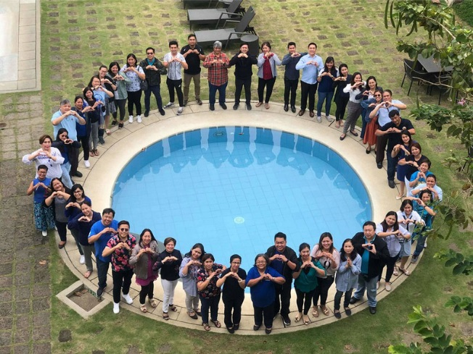

**EXERCISE IN BLUE**

Regular physical activity is an important part of diabetes management and reducing the risk of type 2 diabetes. Whether indoors or outdoors, every step counts to help stay healthy!

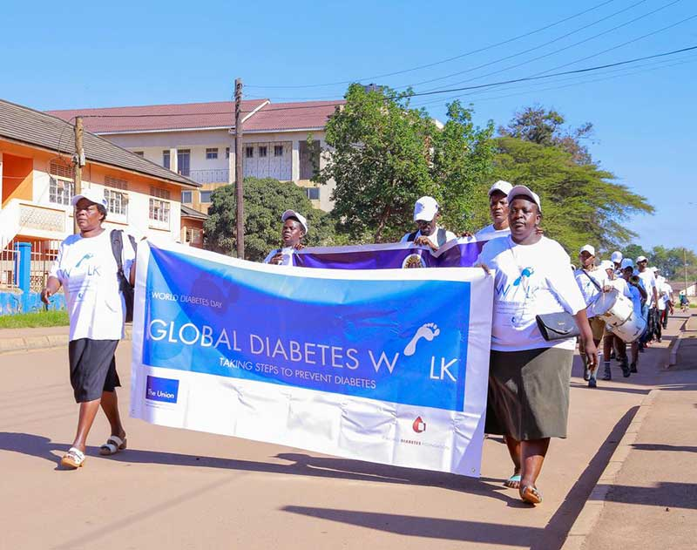Join the [**Global Diabetes Walk**](https://www.globaldiabeteswalk.org/), an initiative created by the World Diabetes Foundation in support of World Diabetes Day. Take to the streets to raise awareness of the impact of diabetes and the importance of physical activity. If outdoor activities in your community are restricted, walk or exercise in your home or workplace and encourage your friends, family and colleagues to join in.

Whichever way you exercise make sure to wear blue and show your support for #WorldDiabetesDay and the #EducationToProtect campaign.

**Follow World Diabetes Day 2022 on the following channels:**

* Facebook: [**@worlddiabetesday**](https://www.facebook.com/worlddiabetesday)
* Instagram: [**@intdiabetesfed**](https://www.instagram.com/intdiabetesfed/)
* X (formerly Twitter): [**@intdiabetesfed**](https://www.twitter.com/intdiabetesfed)
* LinkedIn: [**@internationaldiabetesfederation**](https://www.linkedin.com/company/91593/)

[**Shine a light on diabetes**](https://worlddiabetesday.org/get-involved/shine-a-light-on-diabetes/)

Since the introduction of the blue circle in 2006, monuments, buildings and homes around the world have been lit blue for diabetes awareness on World Diabetes Day. Keep the tradition going by organising a blue lighting in your area this November.

From a local or globally recognised landmark to your workplace, home, front garden or bedroom, every lighting counts!

* Visit our [**Flickr album**](https://www.flickr.com/photos/idf) for inspiration
* Do you have a blue lighting confirmed? Share it with us by uploading the details to [**our activities map**](https://www.worlddiabetesday.org/activities)

**PROMOTE THE BLUE CIRCLE**

The blue circle is the global symbol for diabetes awareness and the logo of World Diabetes Day. There are many ways you can help promote the global symbol of diabetes awareness:

* Wear blue for diabetes
* Wear the blue circle pin or bracelet – [**available to buy here**](https://worlddiabetesday.org/resources/wdd-2019/merchandise/)
* Persuade a Member of Parliament, celebrity, or high-profile individual in your community to wear the blue circle pin. Don’t forget to get a picture, keeping in mind any physical distancing measures in place
* Promote the [**blue circle selfie app**](https://worlddiabetesday.org/resources/wdd-2019/blue-circle-selfie-app/)
* Include the blue circle in all of your correspondence and promotional materials
* Use the blue circle as your profile picture on Facebook
* Find a great profile picture on Facebook and use our frame to promote the blue circle!